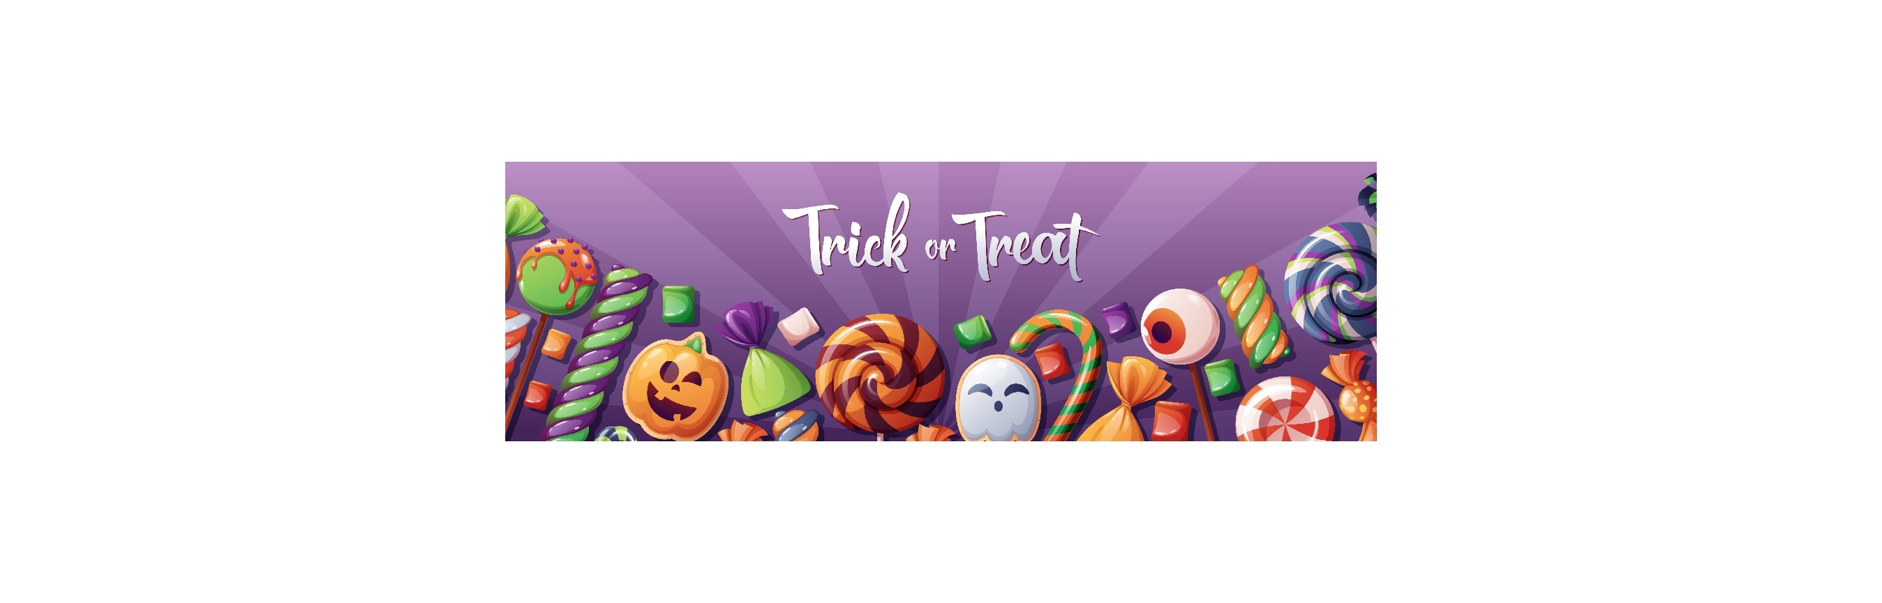
MEF Trunk or Treat 2025 | Saturday, October 4, 2025
MHS Parking lots
VENDOR/TRUNK PARTICIPANT INFORMATION AND RULES
GENERAL VENDOR INFORMATION

Set-up
You will have until 4:00 pm to set up. If you need more time, please feel free to let Jane Wright or Heidi Peebles know. We are happy to accommodate. There is NO driving in the Mishawaka High School parking lot between 4:00 and 7:30 pm.

Booth Space
All businesses or other activity must be conducted within the designated area only. Please do not plan on games for your trunk area, it would slow up the line. MEF will place you in a different area than the trunk area if you would like to have a game or activity. Tents must be weighted. All spaces are on asphalt.

Closing & Tear Down
You may not tear down and leave the parking area before 7:30 pm. Once the Event concludes at 7:30 you may tear down your booth space and drive in the parking lot area.

Parking
There is no parking at your vendor space or in the area of the Trunk or Treat unless you plan to use a car for distribution of treats. After unloading and setting up, all vehicles must be moved to the designated parking areas outside of the market.

Fees and Refunds
Application fee of $50 is required with the application. The application fee is waived for non-profit organizations and individuals and food trucks. Application fees received and processed from accepted vendors are non-refundable, no exceptions. *Note: Electric and water are available for food truck vendors only.*

Weather
In the event of severe weather, the event will be cancelled. This will depend on the severity of the storm. We will attempt to give a 48-hour notice. However, the weather in Indiana can be unpredictable.
TRUNK OR TREATERS
Vendors who fall under the Trunk or Treat category are welcome and encouraged to:
- Set up a booth, table or trunk of a car
- Bring individually wrapped candy that has been store bought or a child-friendly giveaway to pass out to trick or treaters
- Bring business paraphernalia to promote your business
- Decorate the booth, table or trunk of car to reflect a Super Here or Halloween theme
- Dress up in costumes

REQUIREMENTS/ RESTRICTIONS
- Item distributed must be individually wrapped and store bought
- Provide items for 2000 trick or treaters
- Homemade food, beverages, items, etc. are not acceptable.

ALCOHOL:
- Alcohol is not permitted on the Mishawaka High School grounds.
FOOD & BEVERAGE (Food Trucks)
Food and beverage vendors must have the necessary permits, at least seven (7) days prior to the event, with the St. Joseph County Health Department (if needed). Alcohol sales are not permitted on the Mishawaka High School parking lot.



